Restore Riverview database from backup

* Delete current Riverview database
  + Make sure you close all the queries that are using the Riverview database.
* 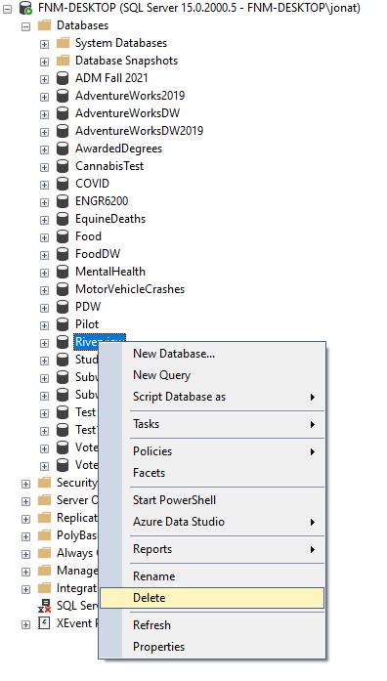
* Right click on the Database folder and choose “Restore Database…”
* 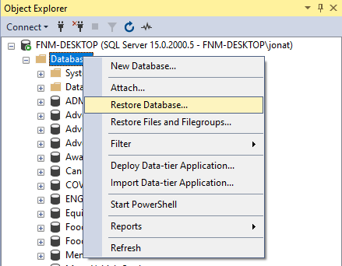

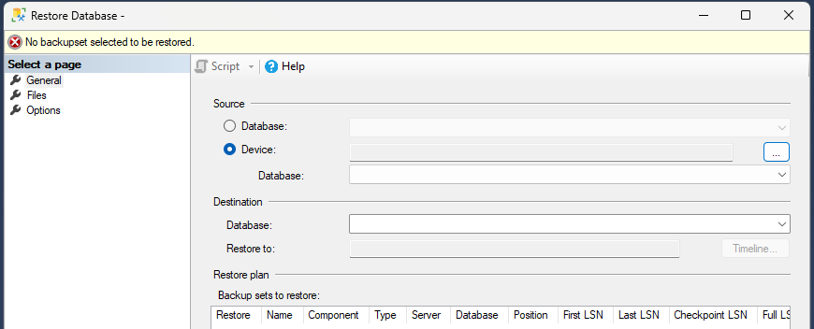

* Click Device and then the button all the way to the right with the three dots

* Click Add and it should bring you to the folder we originally used. Choose the Riverview.bak file

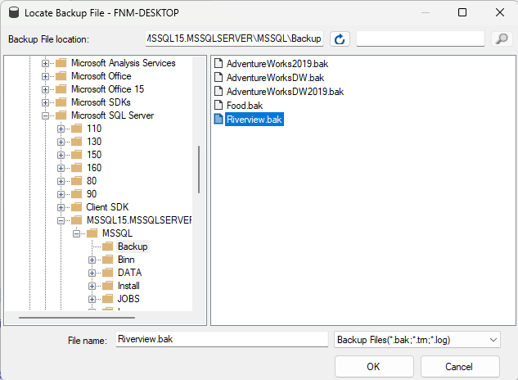

* Click OK, then OK again, and you will be at this screen.

* Click OK one more time and your database will be restored.

